Attendance Policy
2026-2027



Ystruth Primary School
Ysgol Gynradd Ystruth

Adopted by Governing Body: January 2025
Date to be reviewed: January 2027

Why is Good Attendance Important?

Regular school attendance has a positive effect on learners and a strong impact on learner outcomes, standards and progression. Good attendance also has a positive effect on emotional and physical wellbeing.
Article 28 of the UNCRC: Children and young people have the right to education

Roles and Responsibilities

Promoting good attendance is the responsibility of all members of the school community. Within the school, two senior leaders have overall responsibility for attendance: Mrs M Miller (headteacher) and Mrs A Skuse (deputy headteacher). There is a clear list of roles and responsibilities for key members of staff in relation to attendance linked here:
Ystruth Primary Attendance Roles & Responsibilities

Engagement with Parents
Phone calls
- The attendance clerk will contact parents by telephone for learners who are absent without contact from home on day 1, 2 and 3 as appropriate.
- Class teachers will contact parents by telephone for learners who have been absent for three consecutive days to check in and discuss a plan for a return to school.
Letters (Parent Mail)
- At the start of the school year, we send out a letter to parents outlining the importance of good school attendance and sharing our whole-school target.
- This is followed by monthly attendance updates to the parents of each child within the school, informing them of their attendance to date.
- Where appropriate, if attendance dips below 90%, parents will receive a letter informing them that we are concerned about their child’s attendance and that unless attendance improves we will undertake an Attendance Improvement Meeting (AIM) to establish an agreed plan for how we will work together to improve attendance. School may engage the support of our Family Engagement Officer at this point or discuss a Families First referral with parents.
- Where appropriate, school will send a letter once a pupil has accrued 5 days/10 sessions unauthorised absence.
- If there is insufficient improvement in attendance in 2-4 weeks following the above letter, parents will be invited to attend an Attendance Improvement Meeting (AIM) with Mrs Miller or Mrs Skuse where an agreed action plan will be implemented.
- Where appropriate, school will send a letter requesting medical evidence to support authorisation of absences when three or more days have been missed (within one term).
- Where appropriate, school will send a letter informing parents that we will require medical evidence to support authorisation of absences when a child has missed five or more days of school (within one term). If medical evidence is not provided, absences will be recorded as Unauthorised (O).
- If there are further unauthorised absences following the above letter, parents will be invited to attend an Attendance Improvement Meeting (AIM) with a senior leader on the campus where an agreed action plan will be implemented.

Meetings
- When an Attendance Improvement Meeting (AIM) takes place, an action plan will be developed between the parents and school. The school leader may discuss a Families First referral with parents at this meeting. Parents will be informed of a potential referral to the Education Welfare Service (EWS) following a two-week review of progress. If parents do not attend this meeting, the case will be discussed with the Education Welfare Officer (EWO).
- A review AIM will take place after two weeks. Senior leaders will discuss the case with the EWO if parents do not attend this review meeting and/ or if there is no sustained improvement/ engagement with attendance.

Education Welfare Service
- School may make a referral to the EWS if attendance does not improve following the above steps; if a child’s attendance is below 90% with at least five Unauthorised (U/O) absences; or the case meets the criteria for a Fixed Penalty Notice to be awarded.

Rewarding Good Attendance

- An award is given to the class with the highest attendance each week. The class is celebrated on media outlets and learners receive additional playtime as a reward.
- An attendance trophy is given to the class with the highest attendance each week.
- Those with 100% attendance for a week will receive two class dojo points.
Education Other Than At School (EOTAS)

EOTAS is generally designed as a short-term placement to support learners to return to mainstream education.

Reduced Timetables
Part-time timetables are only to be used in exceptional circumstances as a short-term measure, (generally no more than a six-week period) with the intention of returning to full time attendance at school sooner, if feasible. We ensure learners who are on a part-time timetable, receive a full education, where this is appropriate for individual learners. This could include for example, providing the learner with on-line or hard copy resources and work. Where a part-time timetable is required, we inform the local authority of arrangements.
POLICY AND GUIDANCE FOR SCHOOLS ON THE USE OF REDUCED TIMETABLES September 2021

Flexi-Schooling
Flexi-schooling is an arrangement between parents of a child and the school where the learner is registered in the normal way, but only attends the school on a flexible basis. The rest of the time the learner is educated at home but will continue to remain on the school roll. There is no guaranteed right for parents to flexi-school; it is entirely at the discretion of the head teacher and local authority whether to agree. Flexi-schooling means that children who may be home educated in part are still in mainstream school for some of the time and are therefore able to experience its benefits. This approach may be adopted for a variety of reasons, and is sometimes done as a short-term measure.

Elective Home Education (EHE)

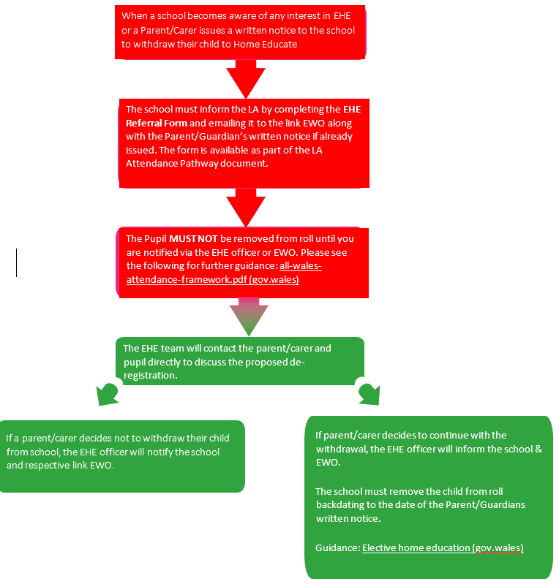

Learners from Gypsy, Roma and Traveller communities

National data shows that attendance amongst Gypsy, Roma and Traveller learners is generally lower than their peers and as a school, we recognise that there are many reasons for this. We aim to work with Gypsy, Roma and Traveller families to ensure their children attend school as regularly and as frequently as possible with the aim for attendance to be at least 380 sessions, which equates to 190 days, during any school year.

Holidays in term time and extended overseas trips

Parents must apply in advance to take holidays or overseas trips in term time. As a general rule, we do not authorise any holidays taking place in term-time. However, we do consider requests on an individual basis and where appropriate we will invite parents to discuss any such proposals. Welsh Government guidance only allows schools to agree to absence for a family holiday or trip if they believe there are special circumstances that warrant it. If a school agrees to the absence and the pupil goes on holiday or trip for 10 days or less, the absence is authorised (code H). If the school does not agree to the absence and the pupil goes on the holiday or trip, the absence is unauthorised (Code G). The Brynmawr cluster has an agreed approach to holidays. The first 10 days (unless in exceptional circumstances) will be unauthorised (code G). The 11th day, will result in a Fixed Penalty Notice (FPN).

Absence Related to Religious Festivals

Our school follows the Wales Association Standing Advisory Councils for Religious Education (WASACRE) advice:
- Any application made by a parent for their child to receive an authorised absence for religious observance is treated with sensitivity and considered carefully and fairly
- Absence should only be authorised for a date ‘exclusively set apart by the religious body’ as detailed here: School attendance and religious festivals guidance 2023
- If a date has not been ‘exclusively set apart’ by the relevant religious body, it is suggested that the head teacher enquires whether the learner/s can fulfil their religious observance outside of school hours
- If a festival falls on a weekend or during a school holiday, absence taken on a school day for that festival would not be authorised
- Similarly, absence taken on a school day either side of a festival that has been ‘exclusively set apart’ by the relevant religious body would not be authorised.

Punctuality

Why is being on time for school important?
It is important that children arrive at school on time so that they do not miss out on any learning time. Being late to school can negatively impact the wellbeing of children.

- The start of the day is 8.50am. It is the responsibility of parents to ensure that your child is in the agreed school collection area at 8:50am.
- Children arriving at later than 9.10am must come through the main entrance. All other doors are locked at 9.10am for security reasons.
- If a child is late and the registers have been taken they will receive a late mark (L code) if they arrive by 9.30am.
- If they arrive after 9.30am they will receive an unauthorised absence (U code). This will be noted on your child’s attendance record and may result in the EWO issuing a fixed penalty notice.
- You will be invited to an attendance management meeting (AIM) with the school if your child is persistently late.

Overview of Attendance Codes

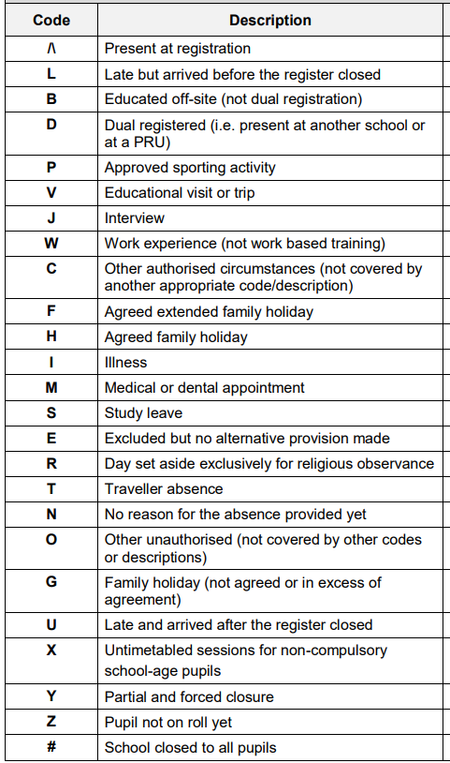

Links to Relevant Documents

- Improving school attendance | GOV.WALES
- School attendance codes: guidance | GOV.WALES
- Penalty notices for regular non-attendance at school: guidance | GOV.WALES
- School attendance and religious festivals guidance 2023
- Home education - Welsh Government Guidance
- POLICY AND GUIDANCE FOR SCHOOLS ON THE USE OF REDUCED TIMETABLES September 2021
- EWS Attendance Pathway Document 2023.docx
- Guidance on school attendance codes

Families First is a Welsh Government programme designed to improve outcomes for children, young people and families. It emphasises prevention and early intervention for families.

