
SAFEGUARDING TEAM
Safeguarding is everyone’s responsibility.
It is the action that is taken to promote the welfare of children and protect them from harm.


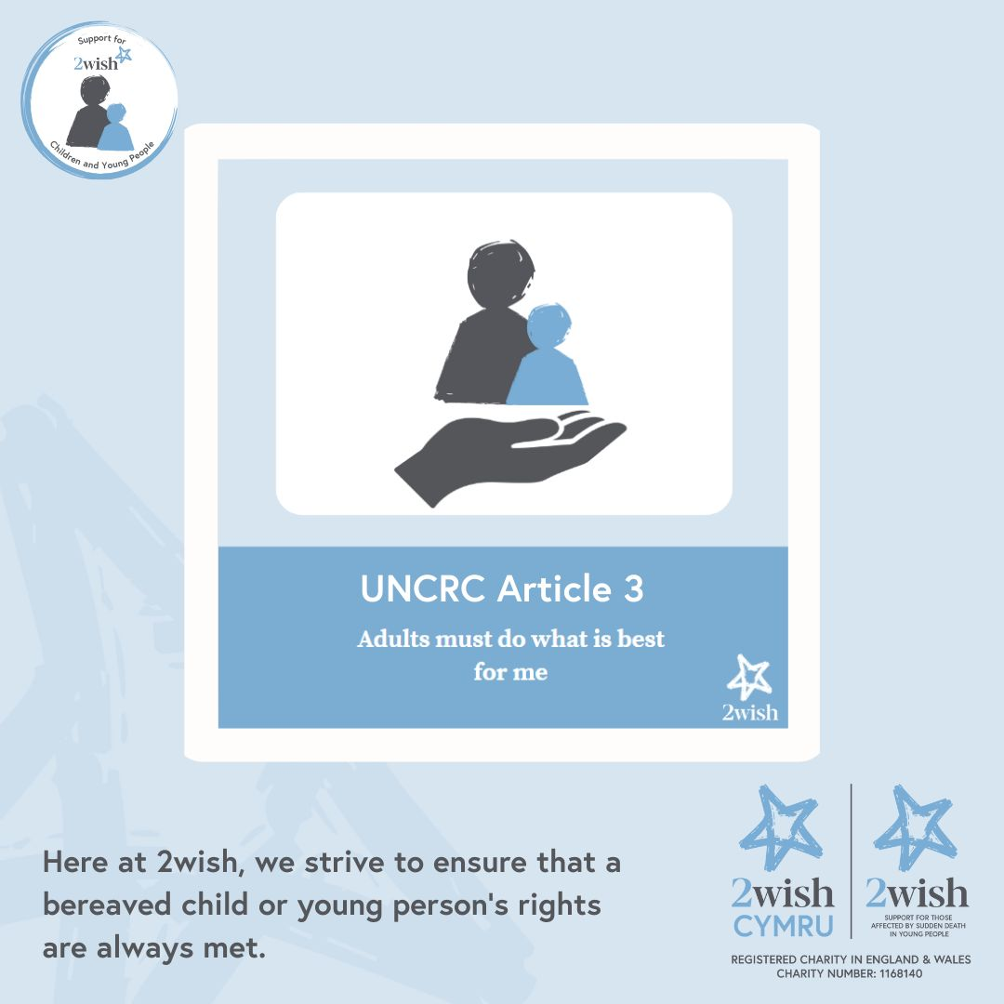



The Designated Safeguard Lead Person is
Mrs Melanie Miller
Headteacher

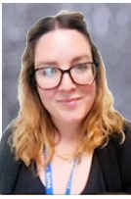
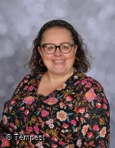

The Designated Deputy Safeguard Person is
Mr Shaun Pugh
Class teacher/SLT
The Designated Deputy Safeguard Person is
Mrs Joanne Stonuary
ALNCo
The Designated Deputy Safeguard Person is
Mrs Amy Skuse
Deputy Headteacher
Concerns about a member of staff please report to Mrs Melanie Miller or Mrs Amy Skuse and/or Mrs Joanne Stonuary in their absence.

Concerns about the Headteacher please report to the Chair of Governors – Mrs Kim Evans (Contact details held in the Main Reception).

