

Dear Parent/Carer,
As you know, attendance is a focus within education, not only at Ystruth Primary School but across the whole of Wales.
Below is information about how we are going to address attendance in Ystruth Primary School and the actions that will be taken.
Our target for attendance for this year is 92%. Attendance is the responsibility of all stakeholders and we really need your support and cooperation to ensure that attendance of all learners improves. It is your responsibility each day to ring school or leave a message via the ParentMail absence line and inform us of your child’s absence.

Attendance Pathway:
Mrs White will contact home on day 1, 2 and 3 if no reason for absence has been communicated from home.

Medical evidence could include prescriptions, appointments, hospital letters, medical letters!

After day 3 a letter will be sent out asking for medical evidence so any further day/s of illness can be authorised.

After day 5 a further letter will be sent out if no medical evidence has been received following the previous letter.

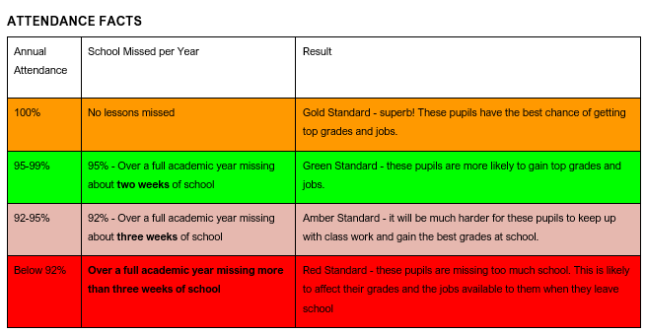

The start of the school day is 9.00am. Pupils that arrive after 9.10am will be issued with a late code ‘L’. Any pupils that arrive after 9.30am will be marked as an unauthorised absence. This could result in the Education Welfare Officer issuing a FPN.
Holidays will no longer be authorised and will automatically be given a ‘G’ code. Only 10 days can be given a ‘G’ code. Any holiday days that go into the 11th day will automatically be issued with a Fixed Penalty Notice (FPN).
We will be tracking attendance of pupils who have attendance below 90% and, in some cases, working in collaboration with the Education Welfare Officer to support pupils and their families.

If you would like to discuss this further, please do not hesitate to contact Mrs Amy Skuse – Deputy Headteacher.
Many thanks for your continued support.

